Chapter 1:

How to record a 12-lead ECG

**Alan Davies and Alwyn Scott**

Physiology

Sinoatrial node

Interatrial/internodal tracts

Atrioventricular node

Bundle of His

Right bundle branch

Left bundle branch

What is an ECG

Patient positioning

Electrode placement

Attaching the cables

The machine

What to write on the ECG

Quiz

Summary of key points

Physiology

The heart is located in the chest between the lungs in the mediastinum. It is surrounded by a protective sac called the pericardium (figure 1.1). Essentially the heart is split into four functional chambers; a left and right atrium, and a left and right ventricle (figure 1.2). Deoxygenated blood (blood with no oxygen in it) is emptied into the right atrium via the vena cava. The inferior vena cava returns blood from the lower portion of the body as the superior vena cava returns blood from the higher portion. This blood is then pumped through the tricuspid valve into the right ventricle. Blood is then passed into the lungs via the pulmonary artery where it is oxygenated. Oxygenated blood then returns from the lungs into the left atrium where it can be pumped to the rest of the body by the powerful left ventricle, via the aorta (figure 1.3). The cells responsible for the contraction of the heart muscle are called myocytes. Apart from the hearts mechanical function as a pump it also has an electrical system governing the rate at which the heart beats, controlling in turn how slow or fast the blood and oxygen gets pumped to all the organs and tissues in the body.

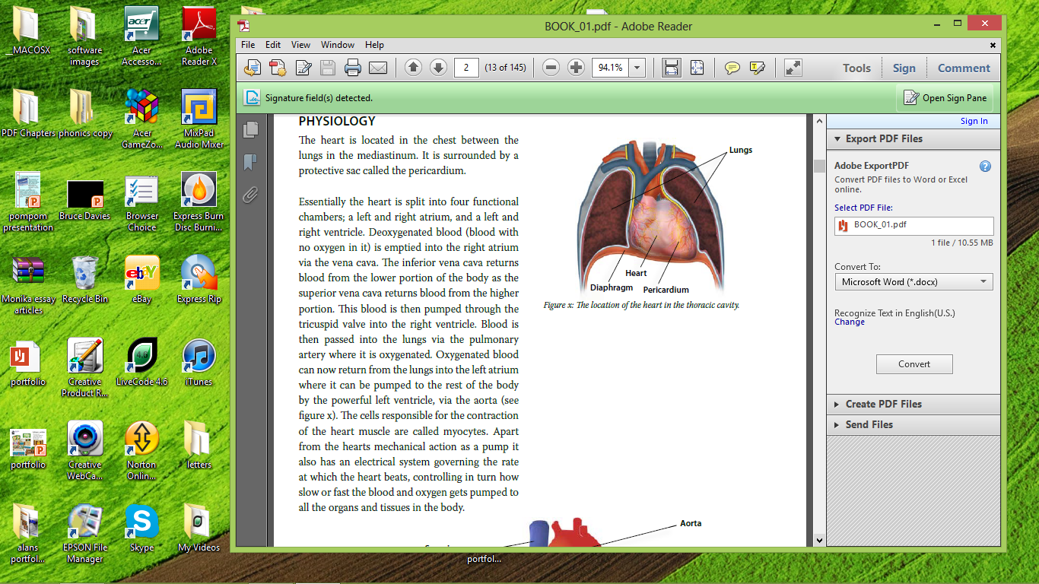

*Figure 1.1: The location of the heart in the thoracic cavity.*

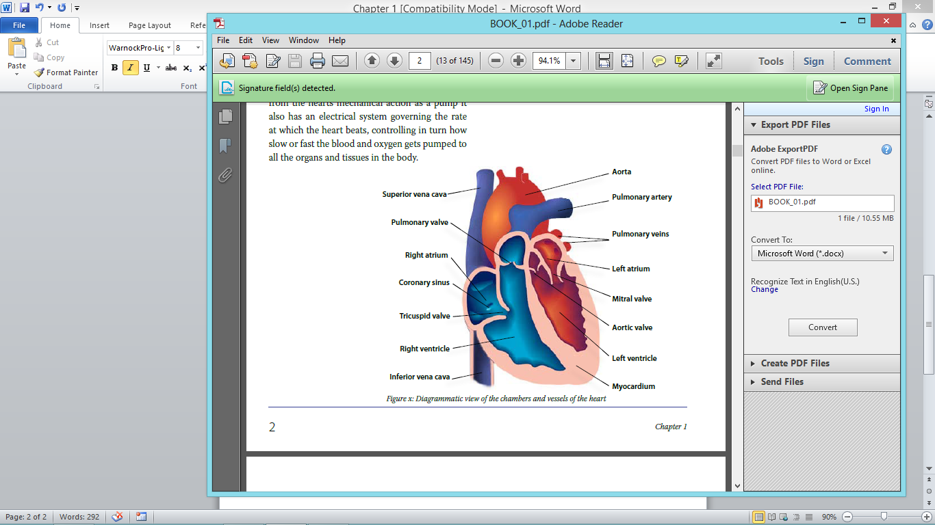

*Figure 1.2: Diagrammatic view of the chambers and vessels of the heart.*

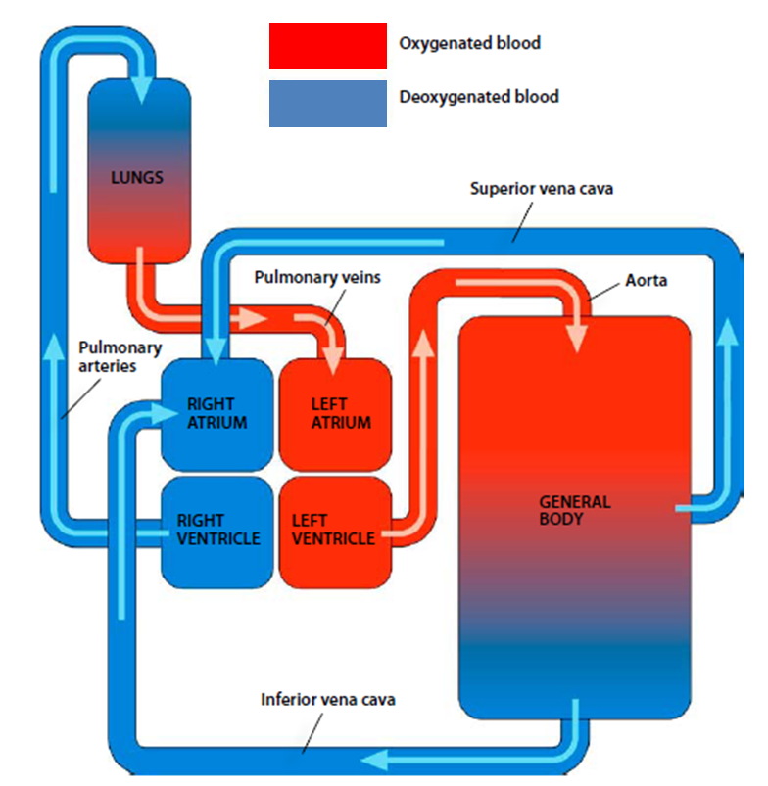

*Figure 1.3: Schematic diagram showing the mechanical function of the heart.*

In addition to the myocyte cells, there are also specialised conduction cells in the heart. These cells possess a quality know as automaticity. This is the ability to spontaneously depolarise via an electromechanical gradient. Depolarisation is a process where by a resting cell becomes gradually more positively charged (figure 1.4). This is accomplished by a sudden influx of positively charged sodium and calcium ions into the cell Alternatively, Repolarisation is the returning of the cell to its resting state following a brief refractory (recovery) period.

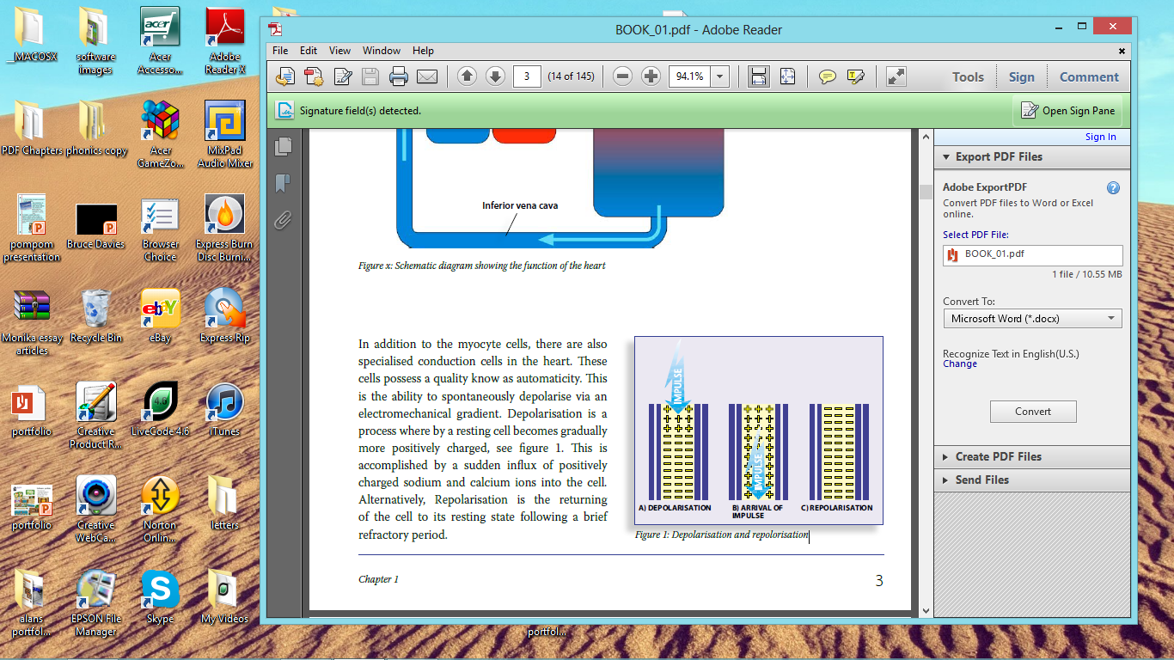

*Figure 1.4: Depolarisation and repolarisation.*

These specialised conduction cells are distributed throughout the heart forming specialised conduction pathways (figure 1.5). Depolarisation occurs in the Sinoatrial node (SAN). This is a collection of self-excitory (pacemaker) cells that normally fire at a rate of between 60-100 Beats Per Minute (BPM). The “wave” of Depolarisation moves from the SAN through an intra-atrial tract called Bachmanns bundle into the left atrium and to the Atrioventricular (AV) node. From here the impulse travels down the bundle of His into the right and Left bundle branches and finally into the Purkinje fibres activating the ventricles.

We will now examine the components of the conduction system in isolation to better understand their function. It is also worth noting that every cell in the conduction system can act as a pacemaker when called upon to do so. This provides a backup system should the SAN fail. The lower down the conduction system is activated, the slower the heart rate.

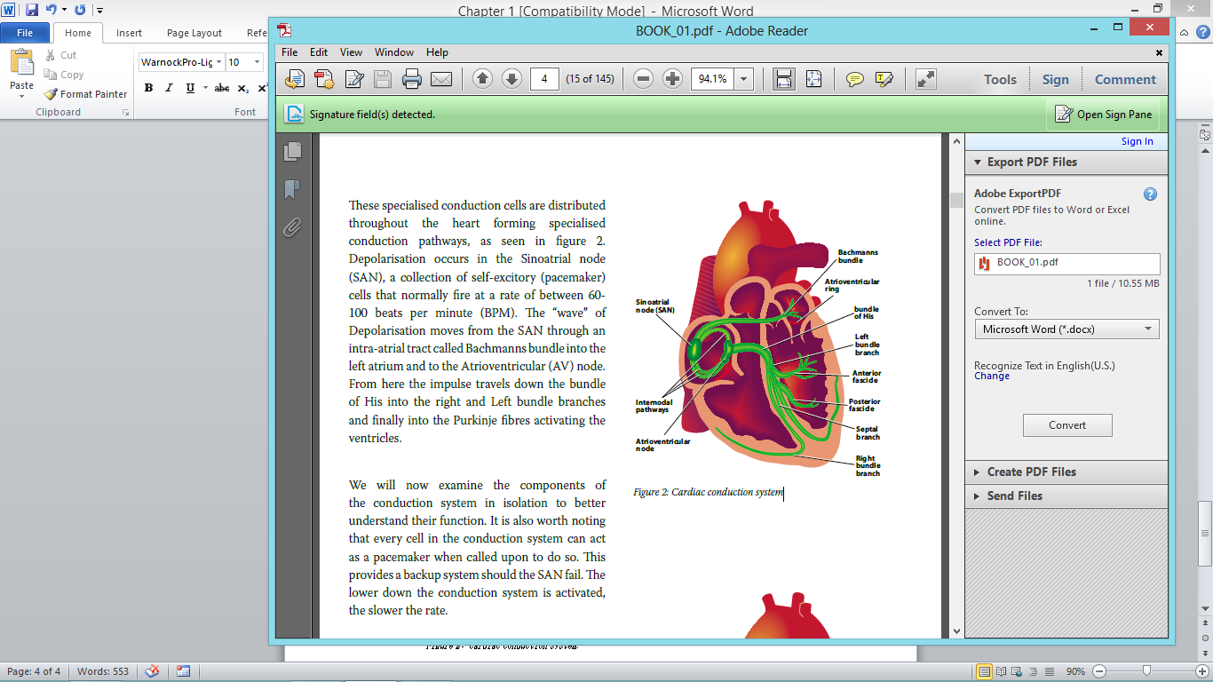

*Figure 1.5: Cardiac conduction system.*

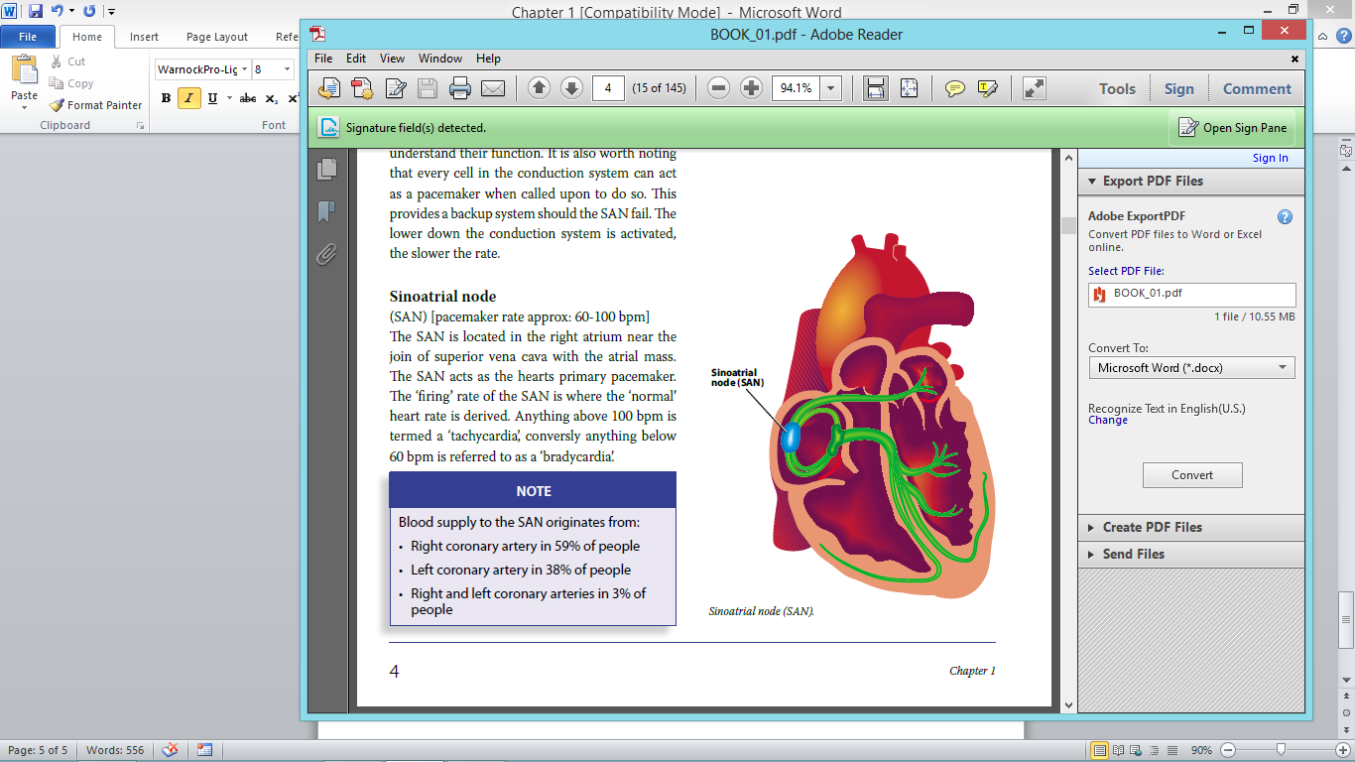

*Figure 1.6: Sinoatrial node (SAN).*

**Sinoatrial node (SAN)**

[pacemaker rate approx: 60-100 BPM] The SAN is located in the right atrium, near the join of superior vena cava with the atrial mass (figure 1.6).

The SAN acts as the hearts primary pacemaker. The ‘firing’ rate of the SAN is where the ‘normal’ heart rate figure is derived from. Anything above 100 BPM is termed a ‘tachycardia’, conversely anything below 60 BPM is referred to as a ‘bradycardia’.

|  |
| --- |
| **NOTE** |
| Blood supply to the SAN originates from:   * Right coronary artery in 59% of people * Left coronary artery in 38% of people * Right and left coronary arteries in 3% of people |

**Interatrial/internodal tracts**

The Bachmanns bundle and iternodal tracts allow the rapid transmission of electrical impulses from the SAN to the left atrium and AV node.

|  |
| --- |
| **NOTE** |
| Some authors argue about the existence of the internodal pathways and/or the Bachmanns bundle and instead believe that impulses generated in the SAN are transmitted through normal cardiac tissue in waves. The analogy of a stone dropped into water creating electrical ripples that eventually reach the AV node is often sighted. |

**Atrioventricular node (AV)**

[pacemaker rate approx: 40-60 BPM] The AV node deliberately delays the impulses from the atria allowing the ventricles time to finish filling and to optimise cardiac output. The atria and ventricles are isoelectrically insulated by the atrioventricular ring. The AV node allows electrical impulses generated in the atria to pass into the ventricular region.

**Bundle of His**

[pacemaker rate approx: 40-45 BPM] Located primarily in the intraventricular septum (figure 1.7). The bundle of His allows the impulse to travel from the atria to the ventricles. The bundle of His bifurcates into the left and right bundle branches.

**Right bundle branch**

[pacemaker rate approx 40-45 BPM] Allows the electrical impulse to travel from the common bundle branch into the right ventricle where the impulse is transmitted through the Purkinje fibres attached to the Right bundle

branch (figure 1.8).

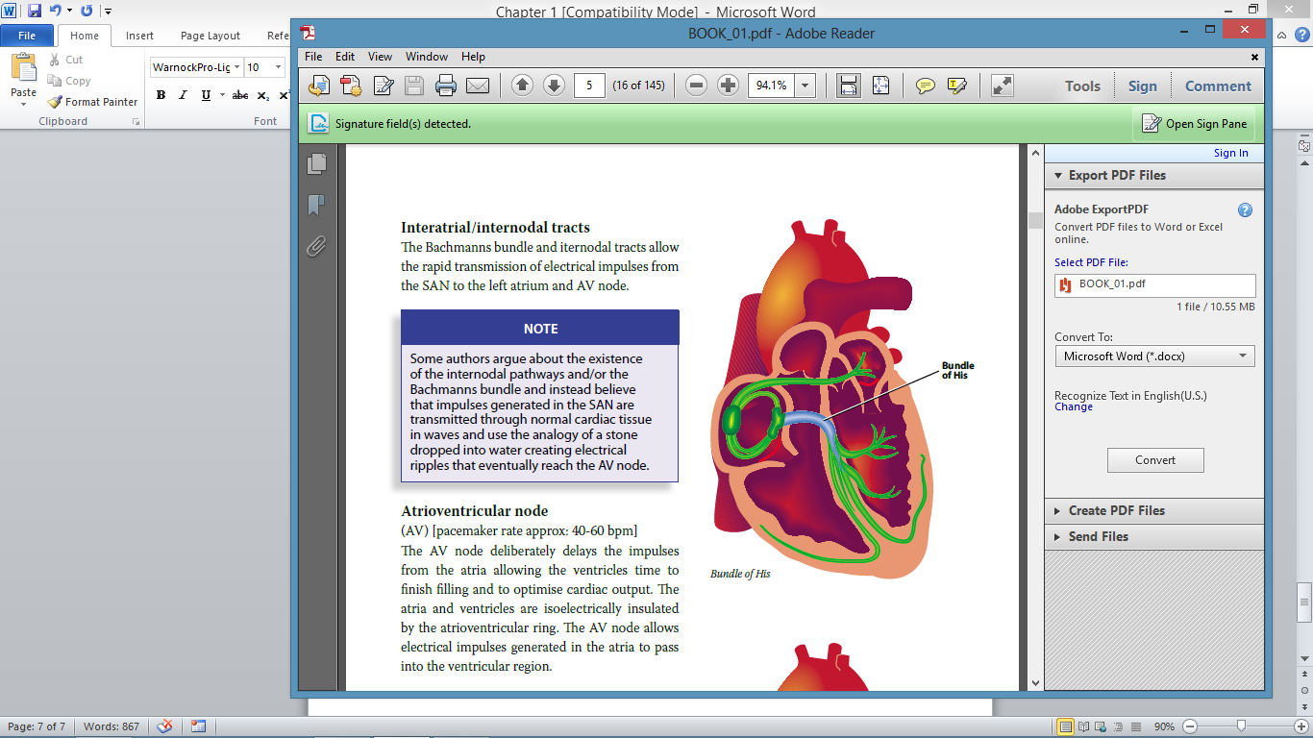

*Figure 1.7: The bundle of His.*

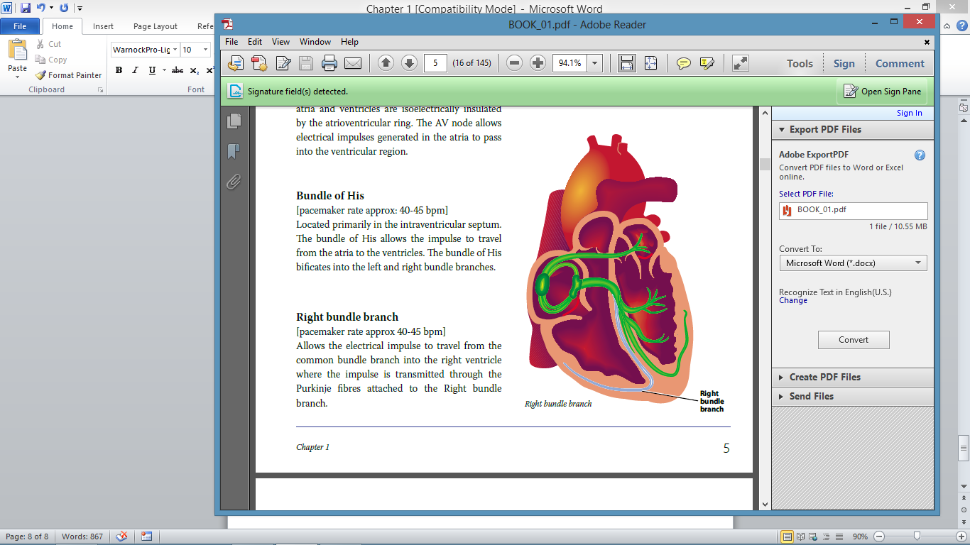

*Figure 1.8: Right Bundle Branch.*

**Left bundle branch**

[pacemaker rate approx.: 40-45 BPM] The Left bundle branch is more complex and has two fascicles protruding from it. This is because the left ventricle is much larger than the right, so by contrast there are more elements to the conduction system of the Left bundle branch. The two fascicles are referred to as the anterior and posterior fascicles (figure 1.9).

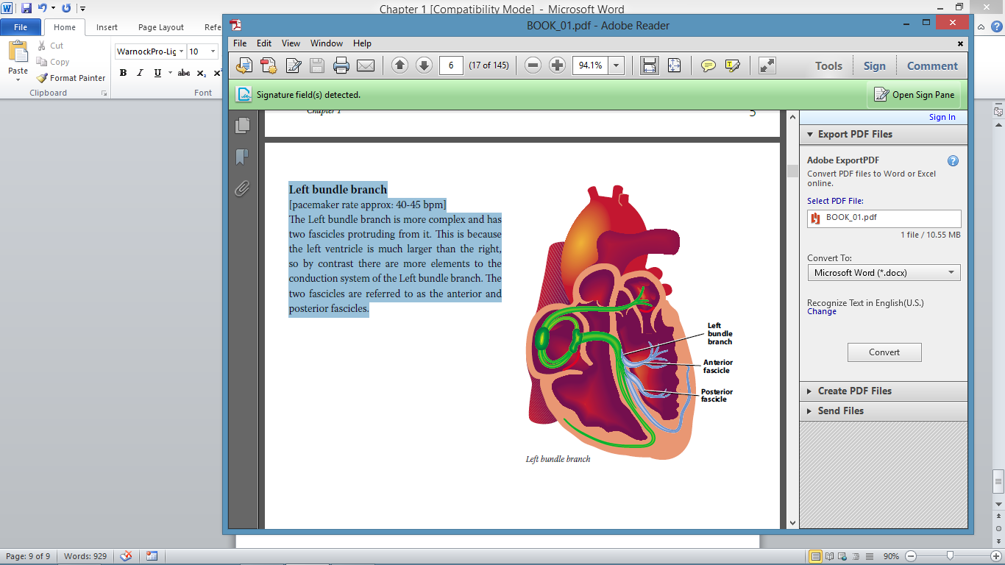

*Figure 1.9: Left Bundle Branch.*

What is an ECG and how are they recorded?

The ECG, short for electrocardiogram is a graphical representation of the electrical activity generated by the heart. This can be of help in diagnosing or supporting the presence of cardiac rhythm disturbances, structural heart disease, acute cardiac emergencies and a variety of other medical conditions. The ECG is a cheap and easily repeatable test. The wide availability of the ECG means that it is available outside of cardiology areas, and is now found on many general wards, GP surgeries and other clinical areas. Electrical activity from the heart is picked up by cables called leads that are attached to a patient. The electrical activity of the heart muscle is then represented by the ECG machine on pre-printed graph paper.

Patient positioning

Prior to recording a 12-lead ECG, the procedure should be explained to the patient and the patient’s consent obtained (figure 1.10). The patient should then be laid back at an angle of around 30 to 45 degrees. This helps to open up the intercostal spaces, allowing easier placement of the electrodes. If the patient is in any other position, including sitting upright, it should be documented on the ECG i.e. ‘recorded with patient sitting upright’.

Sometimes it is necessary to prepare the skin prior to attaching electrodes. If there is visible dirt (blood, soil, water, oil, etc.) this should be removed prior to obtaining a recording. If the patient is perspiring, the adhesion of the electrodes may be affected. In this case an alcohol wipe (or soap and water) can be used to clean the area. It may also be necessary to shave off any excessive chest hair, to ensure better adhesion of the electrodes.

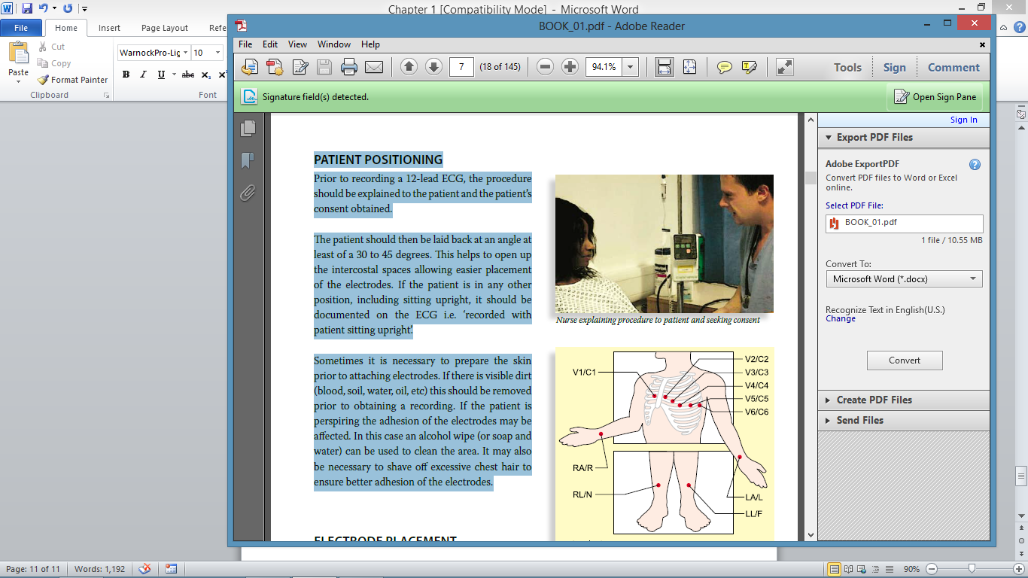

*Figure 1.10 Nurse explaining procedure to patient and seeking consent.*

|  |
| --- |
| **Chest leads**  V1/C1 – 4th intercostal space, right side of the sternal border  V2/C2 – 4th intercostal space, left side of the sternal border  V3/C3 – Diagonally between V2 and V4  V4/C4 – 5th intercostal space, midclavicular line  V5/C5 – Anterior axillary line, in horizontal line with V4  V6/C6 – Midaxillary line, in horizontal line with V5  **Limb leads**  LA/L – Left wrist  RA/R – Right wrist  LL/F – Left leg  RL/N – Anywhere, but usually on the right leg for symmetry |

*Figure 1.11: Electrode positions.*

|  |
| --- |
| **NOTE** |
| Before recording the ECG, check the  equipment, including:  • Paper is loaded  • Power supply  • Presence of all cables/clips |

Step 1

Prior to attaching the electrodes and ensuring good patient position, all clothing on the top half of the body should be removed. The trousers

can be rolled up to allow access to the legs. If the patient is wearing any tights they should also be removed prior to attaching electrodes. The skin is then prepared as necessary (as discussed earlier).

Step 2

First start by attaching the limb electrodes to the arms and legs. When attaching the electrodes to the legs it helps to place them with the tab facing

towards the torso so the cables don’t pull (figures 1.12 and 1.13).

Step 3

The electrodes can then be attached to the torso, starting with V1, which is placed in the fourth intercostal space, just to the right of the sternum.

Electrodes should be placed with the middle of the electrode in the middle of the intercostal space.

One of the problems with the position of V1 is that practitioners sometimes miscount the number of intercostal spaces due to the gap between the clavicle and the start of the rib cage. To avoid this, the patient’s sternum can be felt from the top down until contact is made with the ‘angle of Louis’ (figure 1.14). From here, the fourth intercostal space can be located by feeling diagonally down from the bottom of this point by two intercostal spaces.

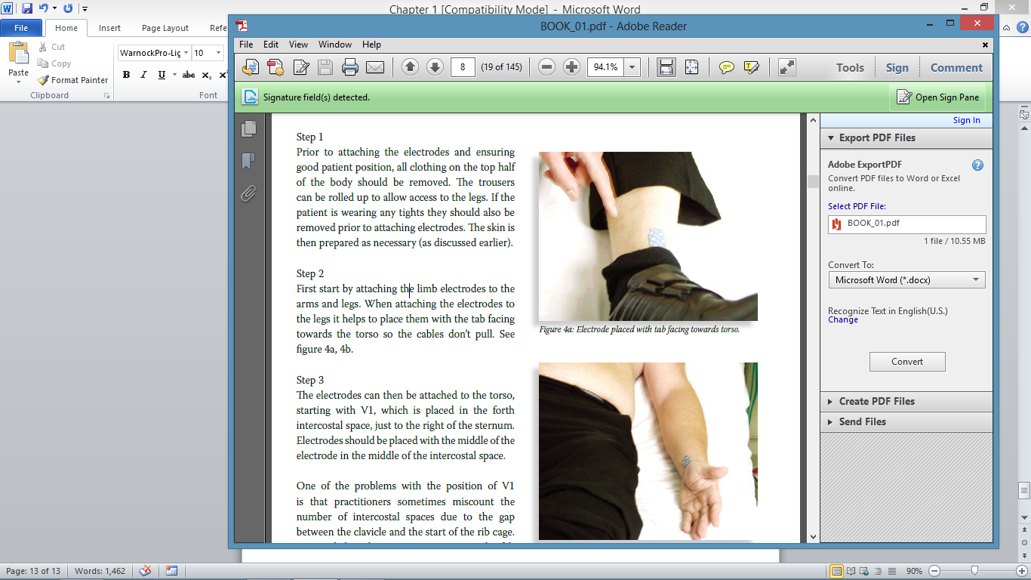

*Figure 1.12: Electrode placed with tab facing towards torso.*

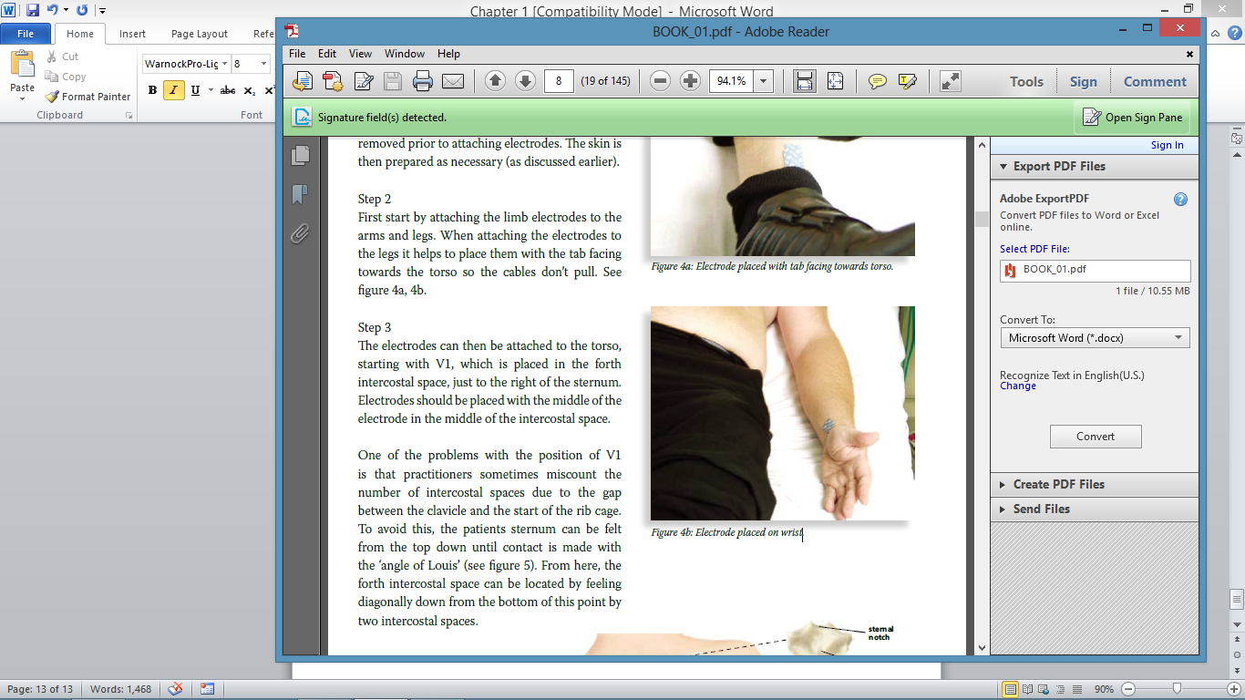

*Figure 1.13: Electrode placed on wrist.*

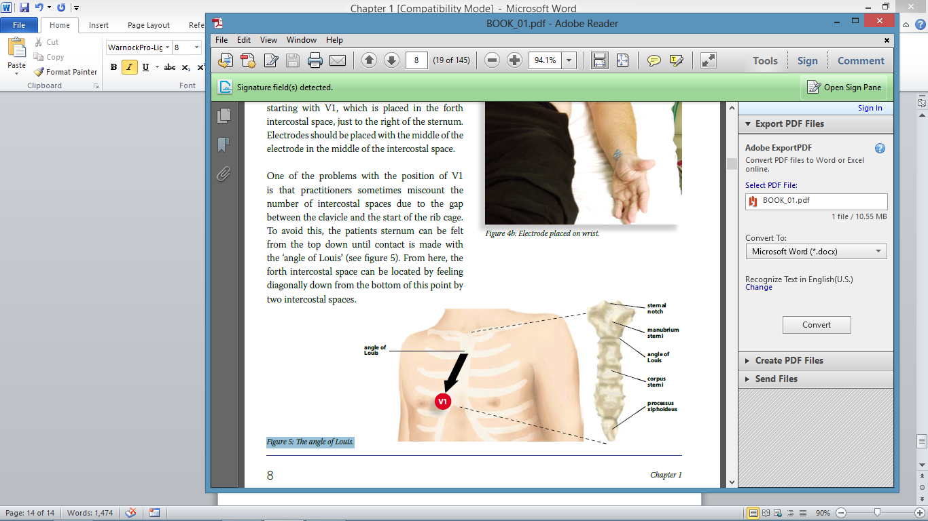

*Figure 1.14: The angle of Louis.*

The next electrode to be placed is V2, this is positioned in the same horizontal line as V1 but on the opposite side of the sternum. Next to be positioned is V4, this is done out of sequence as the position of V3 is relative to that of V4. The V4 electrode is placed in the 5th intercostal space in line with the middle of the clavicle (figure 1.15) this is normally located approximately just under the left nipple.

Now V3 can be positioned, diagonally in between V2 and V4. The V5 electrode is then placed in line with the anterior axilla line and V6 in line with the middle of the armpit (figure 1.16).

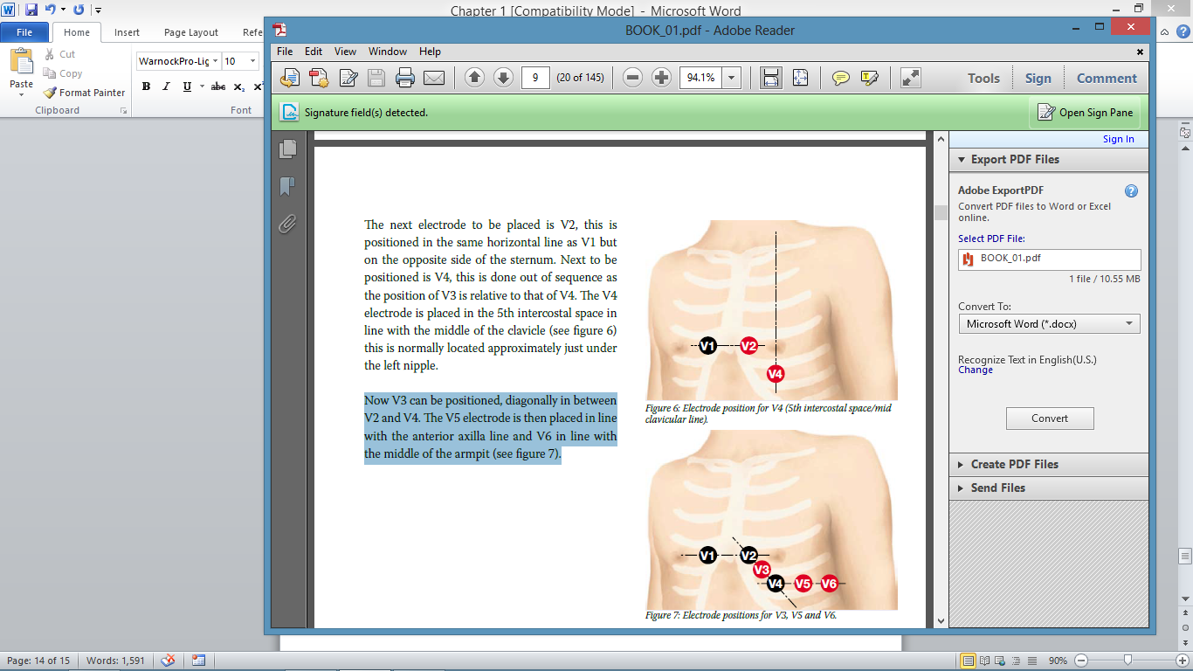

*Figure 1.15: Electrode position for V4 (5th intercostal space/mid*

*clavicular line).*

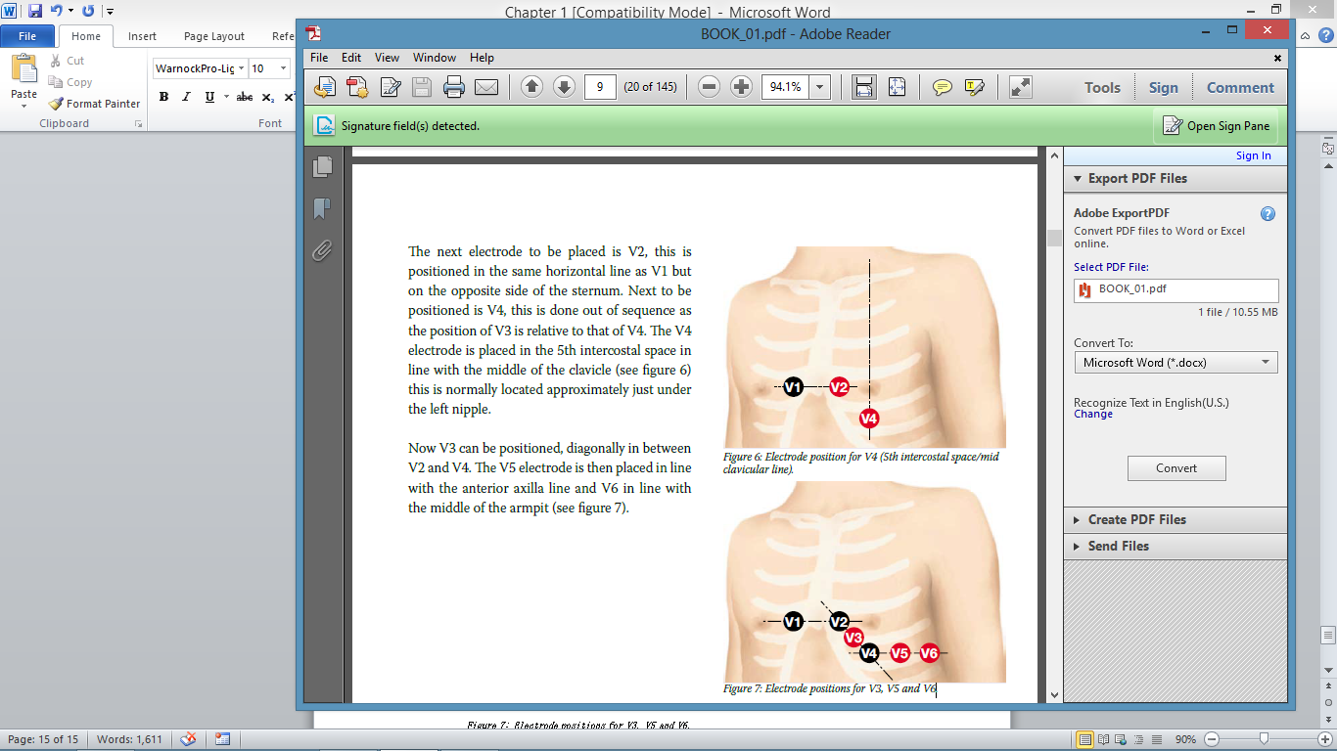

*Figure 1.16: Electrode positions for V3, V5 and V6.*

Women

There is sometimes confusion about the electrode positions in the case of women due to the breast tissue. If the breast tissue is relatively thin or there is a considerable breast droop, then the electrodes may be placed on top of the breast. In most cases and certainly with younger women the electrodes are placed in exactly the same positions, with the exception of V4 which is placed under the breast, taking due care to maintain dignity and seek consent prior to placement. The cables can then be attached to the electrode pads.

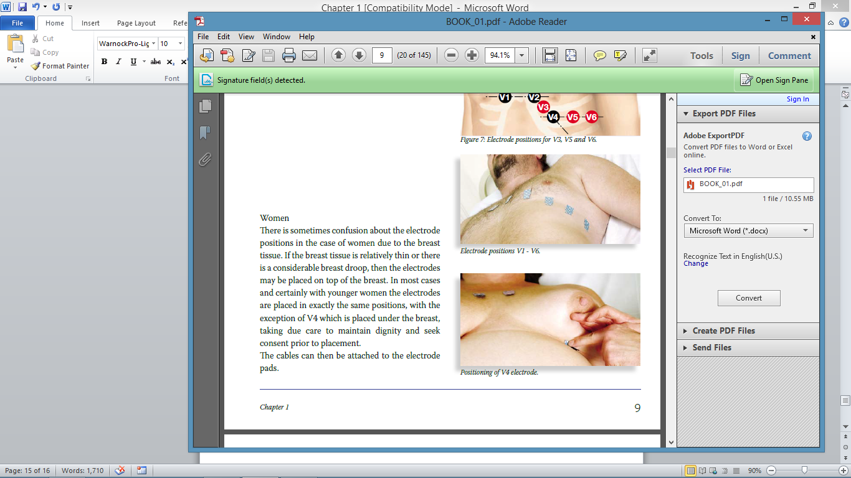

*Figure 1.17: Electrode positions V1 - V6.*

Attaching the cables

When attaching the leads to the electrodes:

• Be wary of pinching the patient’s skin

• Pressing down on the top of the electrode helps to lift the tab, making it easier to attach the clip

• Make sure the cables are not twisted or dangling over the edge of the bed. The patient should be encouraged to relax their arms, shoulders, neck and head prior to recording as this can cause interference on the ECG tracing.

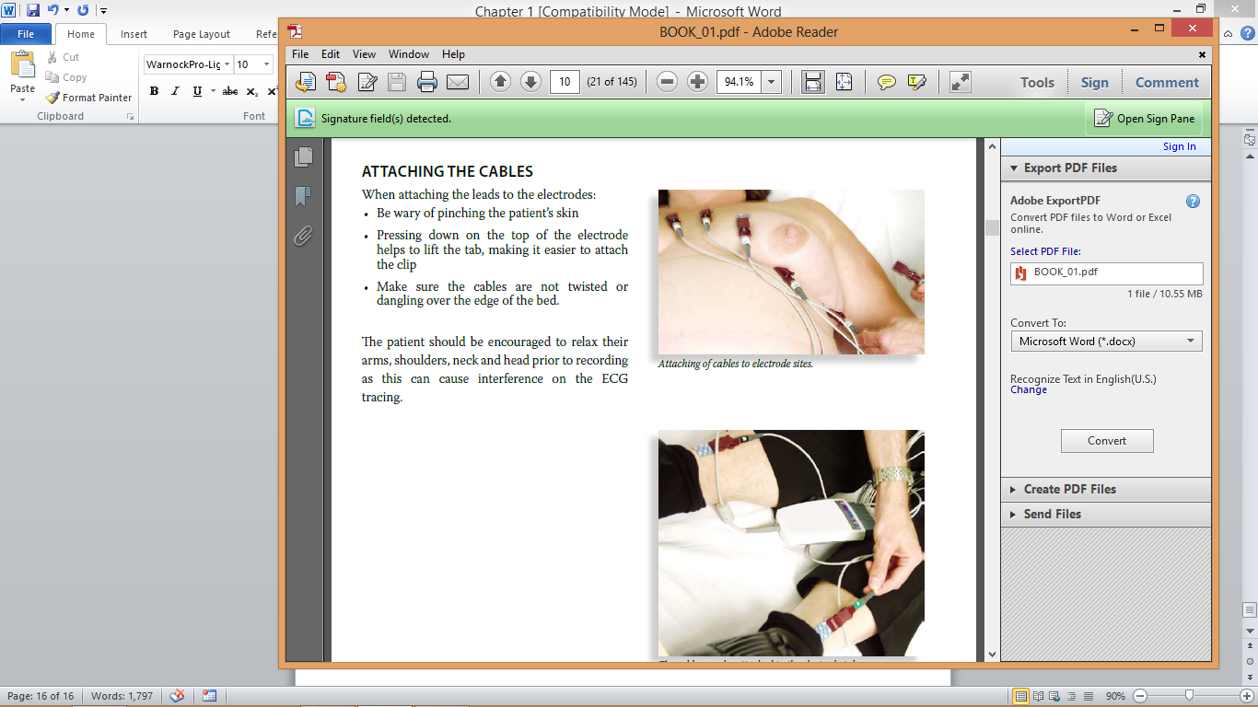

*Figure 1.18: Attaching of cables to electrode sites.*

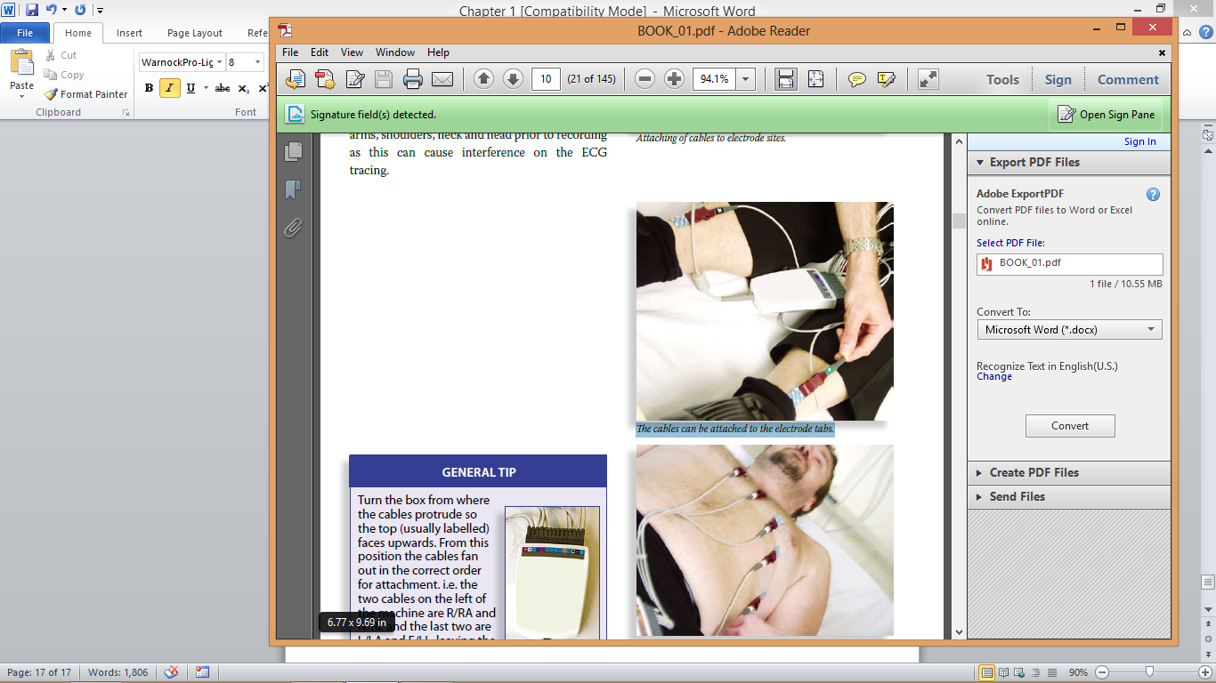

*Figure 1.19: The cables can be attached to the electrode tabs.*

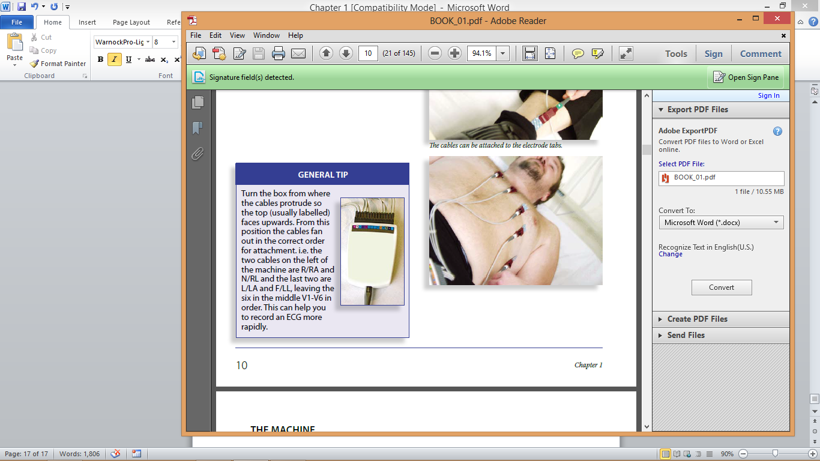

*Figure 1.20: Attaching chest leads.*

|  |
| --- |
| **GENERAL TIP** |
| |  |  | | --- | --- | | Turn the box from where the cables protrude so the top (usually labelled) faces upwards. From this position the cables fan out in the correct order for attachment. i.e. the two cables on the left of  the machine are R/RA and N/RL and the last two are L/LA and F/LL, leaving the six in the middle V1-V6 in order. This can help you  to record an ECG more rapidly. |  | |

The machine

There are many different types of 12-lead ECG recording device. Most share similar features. Specific details can be found in the operator’s manual that comes with the ECG machine.

Check the machine to ensure all leads are being recorded. On modern machines the tracing can be seen on the monitor, older machines usually

have a light which activates if a lead is not being recorded. In such an event, recheck the electrodes are still attached to the patient and

the clips are attached to the electrodes.

It is also important to ensure that the machine is running at the standard calibration and speed and to adjust them as necessary if they are not.

|  |
| --- |
| **STANDARD RECORDING SETTINGS** |
| • Speed 25 mm/sec  • Amplitude 10 mv/mm |

The patient should then be asked to lie still and not move or speak until instructed. This will aid in recording a good quality ECG, and reduce potential interference on the recording.

What to write on the ECG

If you have recorded an ECG it is helpful for diagnosis and/or future reference to document certain pieces of information on the ECG including:

• Patients name, sex, DOB and hospital ID number

• The date and time recorded

• Any relevant observations or symptoms i.e. patient’s blood pressure, heart rate or symptoms i.e. ‘chest pain > 30 minutes’, ‘palpitations’

• Any alterations to recording or position i.e. ‘patient sat upright’.

Quiz

Q1. The V4 electrode should be positioned…

*A) 4th intercostal space mid-clavicular line*

*B) 5th intercostal space mid-clavicular line*

*C) 5th intercostal space mid-axilla*

Q2. The neutral lead ‘N’ must be placed on the right leg

*A) True*

*B) False*

Q3. The specialised cells of the conduction system are said to possess…

*A) Extra electricity*

*B) Action potentials*

*C) Automaticity*

Q4. How many fascicles does the left bundle branch have?

*A) 2*

*B) 3*

*C) 1*

Q5. What should be documented on the ECG after recording?

*A) Patients name, DOB and unit number*

*B) Relevant observations and symptoms*

*C) Date and time of recording*

*D) All of the above*

Q6. The ECG is best recorded with the patient…

*A) Laid down*

*B) Sat bolt upright*

*Answers: Q1=B, Q2=B, Q3=C, Q4=A, Q5=D, Q6=A*

Summary of key points

* Accuracy in electrode positioning is vital for a good quality diagnostic ECG.
* Patients should be relaxed and informed prior to the recording of an ECG, and dignity maintained throughout.
* Relevant information should be documented on the ECG about the patient, including identifying details, symptoms and observations

along with the date and time of the recording.

* As a backup system, any part of the conduction system can take over the role as primary pacemaker. The lower down the conduction system the slower the rate.
* It is important to ensure that the cables are attached correctly to the electrodes with no twisting or dangling.